**CISCO Packet Tracer Lab-Assignment**

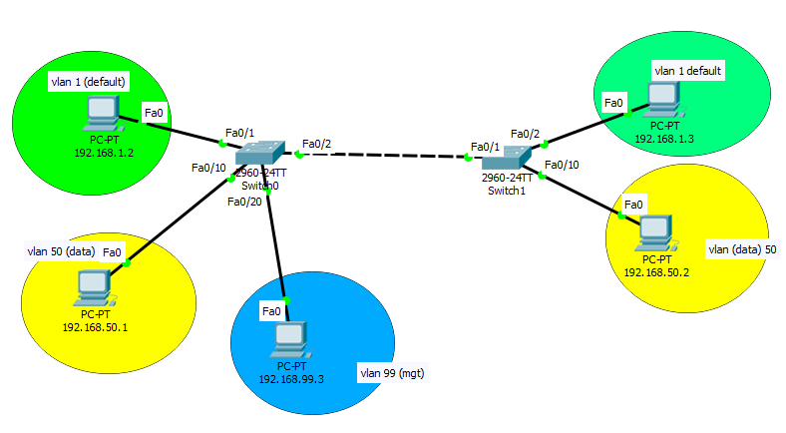

Q3) The above network has three vlan i.e., vlan 1 (default vlan), vlan 50 (data vlan), and vlan 99 (management vlan). PC0 and PC3 are part of vlan 0, PC1 and PC4 are part of vlan 50, and PC2 is part of vlan 99. Management vlan is used for controlling switch by remote login.

a) Assign IP address to all the PCs as shown in the figure above.

b) Make two vlan i.e., vlan 50 and vlan 99 with name data and mgt.

c) Add interface fa0/10 to vlan 50 and interface fa0/20 to vlan 99.

d) Assign IP address to interface vlan 99 so that remote login can be done.

e) Assign a password to vty and enable and try to remote login to switch from PC2.

f) Make interface fa0/2 of switch0 and fa0/1 of switch1 trunk so that it can handle the traffic of vlan 1-99.